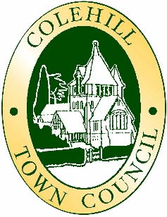
COLEHILL TOWN COUNCIL
GRANTS AND DONATIONS APPLICATION FORM

Before completing this form, please read the instruction notes as these provide examples of why grants may be refused.

It is important that all information is included on this form. The Council will not accept covering letters and will not accept any new information once a decision has been made.

Completed forms must be emailed to: Clerk@colehill.gov.uk
(Note, only digital forms will be accepted)

Requests for grants can be made at any time from 1st April to 31st January. If successful, payment will normally be made within 3 months of application.

Name of organisation
Address
 |  |  | Postcode
Who should we contact with any queries:  Name:  Email:  Telephone: |  | Please state the amount of grant required:  £  (There is no guarantee that this amount will be granted)

1. | How will you spend the money if you are successful in obtaining a grant?

2. | Have you applied for a grant or loan from any other organisations:  (Please state the amount asked for if an application is pending, the amount granted if approved, or the reason why a grant was refused)
 |  | Amount  Pending  £ | Amount  Granted  £ | Reason for Refusal

3. | How will a grant improve your organisation?
4. | How many of your members are residents in Colehill?
5. | What are the objectives of your organisation?

6. | What restrictions exist on who can join your organisation?
7. | If you have been issued with a Council grant previously please explain how it was spent.
8. | How will this grant benefit the residents of Colehill?
9. | Do you have secure tenure at the project site and if you do what type is it?
10. | What facilities are available for disabled people within your organisation?

11. | Have you made any environmental improvements in the last 12 months?
12. | Do you have any environmental improvements planned for the next 12 months?
11. | Please provide any other comments you would like to make here (Please do not add extra pages):

Please enclose with this application the following information:
- A copy of your organisation’s constitution. | - A copy of your most recent audited accounts.
- Any letters of confirmation or other grants/loans secured. | - Business plan for the future operation of your club/organisation.
Further information may be requested at our discretion.

If you are successful you will be paid via BACS transfer. Please provide your account details:
Account Name

Sort Code

Account Number

Signature: | Please print name:
Date:

